Raise ye the stone or cleave the wood to make a path more fair or flat;
Lo, it is black already with blood some Son of Martha spilled for that!
Not as a ladder from earth to Heaven, not as a witness to any creed,
But simple service simply given to his own kind in their common need.
-From Rudyard Kipling’s The Sons of Martha, 1907

For as long as humans have been around, we’ve had an obsession with being first. Hillary and Norgay are immortalized as the first to conquer Everest. Neil Armstrong will forever be remembered as the first to walk on the moon. And any internet comment section will demonstrate the compulsion to claim this same singular achievement: First!
Naturally, we can’t help but wonder who it was that pioneered our profession.
Who was the first engineer? Let’s review some of the candidates.

Imhotep (2650 – 2600 BCE)
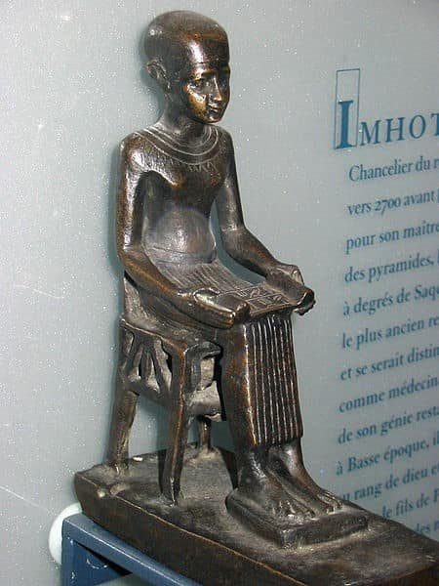
A statuette of Imhotep on display in the Louvre. (Photo courtesy of Hu Totya.)
Imhotep was chancellor to the Egyptian pharaoh Djoser, and his engineering claim to fame is the design of the Pyramid of Djoser. Located in the Egyptian necropolis of Saqqara, the Pyramid of Djoser was the first of the now-famous Egyptian pyramids.
The Pyramid of Djoser is a step pyramid, consisting of six mastabas (sloping rectangular prisms) layered one on top of another, in contrast to the smooth face of the more familiar Great Pyramid of Giza. The limestone-based step pyramid reaches 62 meters (203 feet) high, with a base measuring approximately 109 by 125 meters (358 by 410 feet).
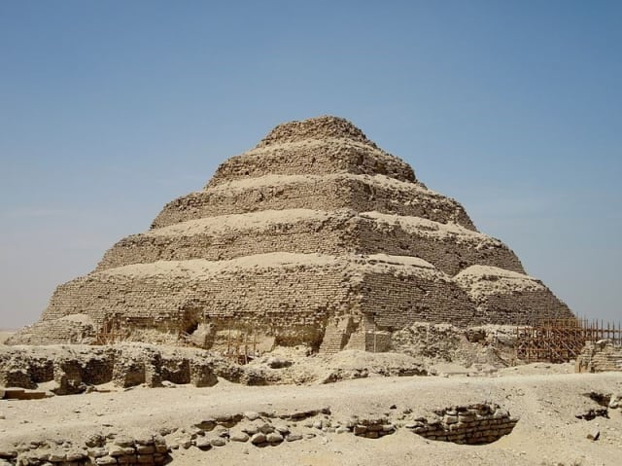
The step Pyramid of Djoser at Saqqara, designed by Imhotep. (Photo courtesy of Olaf Tausch.)
In addition to kicking off the whole pyramid craze, Imhotep may also have been the first person to use stone columns to support a building.

Archimedes (287 – 212 BCE)
“Archimedes Thoughtful” by Domenico Fetti, 1620.
Among the most famous of the ancient Greeks, Archimedes is credited with a number of engineering achievements. Perhaps the best known of these is his “Eureka!” moment, in which he devised a method to calculate the volume of irregularly-shaped objects by submerging them in water.
Archimedes is also credited with designing the transport ship Syracusia, a 110 meter-long vessel said to have been the largest ship of classical antiquity. This size of this ship necessitated the invention of the Archimedes’ screw, a tool used to pump water that remains in use today.
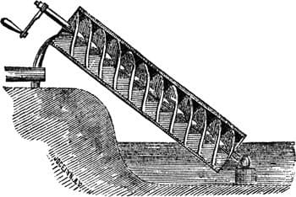
Illustration of an Archimedes’ screw being used to raise water.
Finally, Archimedes is said to have designed and improved a number of weapons, including catapults, the Claw of Archimedes, and a heat ray consisting of an array of mirrors to sink ships via redirected sunlight.
Ismail al-Jazari (1136 – 1206 CE)
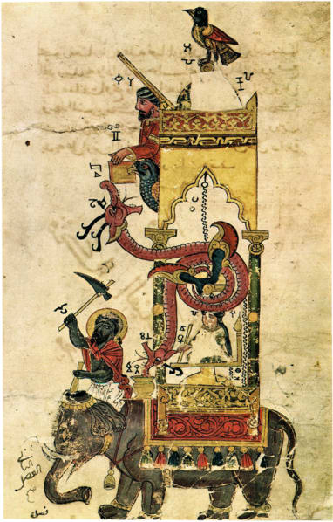
Sketch of the elephant clock from al-Jazari’s manuscript for The Book of Knowledge of Ingenious Mechanical Devices (1206 CE.)
Ismail al-Jazari was a scholar of the Islamic Golden Age, who, unlike the other members of this list, actually served as chief engineer, under the Artuqid dynasty at Artuklu Palace in Mardin. However, he is most remembered for his 1206 work, The Book of Knowledge of Ingenious Mechanical Devices, which describes 100 mechanical devices of his own design.
Al-Jazari’s Lonely Hearts Club Robot Band.
Among these devices are a number of automata, such as a drink-serving waitress and a band of four automatic musicians. al-Jazari also devised several innovative types of clocks, including water clocks, candle clocks, astronomical clocks and the elephant clock pictured above.
Who was the First Engineer?
So, who really was the first engineer? If we’re going by chronology alone, it would seem that Imhotep takes the top spot. But the real answer is a little more nuanced than that. Even before Imhotep’s time, humans had engineered the wheel, lever, pulley, and the rest of the simple machines that served as the building blocks for Imhotep, Archimedes, and al-Jazari.
In the end, I think, the question of first engineer may be unanswerable – engineering is such a broad discipline that labelling anyone the first engineer is bound to be controversial. There have been a number of exemplary contenders throughout history who have defined and redefined the vocation, from the early days of nameless homo sapiens tool users, to the steam engine and the industrial revolution, and to the more recent developments in electrical and computer engineering.
Nonetheless, the topic is ripe for discussion. Who do you think deserves the title? Share your thoughts in the comments below.

